1. Create file name and subdirectories:
File name: mid_exam
Subdirectories: documents, scripts, logs, backup
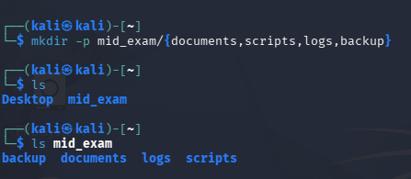
2. File name employee_info.txt and company information and copy this file and rename employee_backup.txt
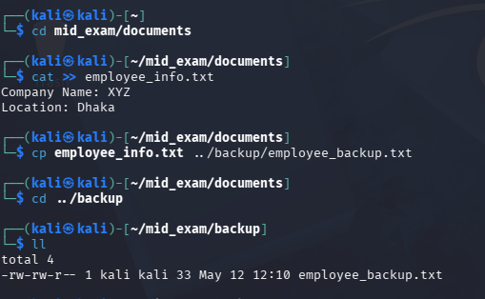
3. shell named scan.sh create echo command
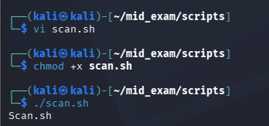
4. System Information:
IP address
Hostname
Logged-in user
Ping test result
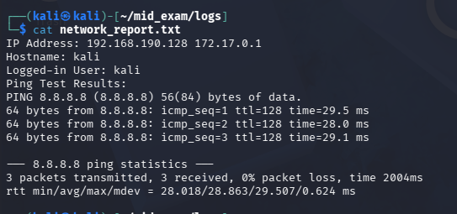
5. Nmap scan scanme.nmap.org
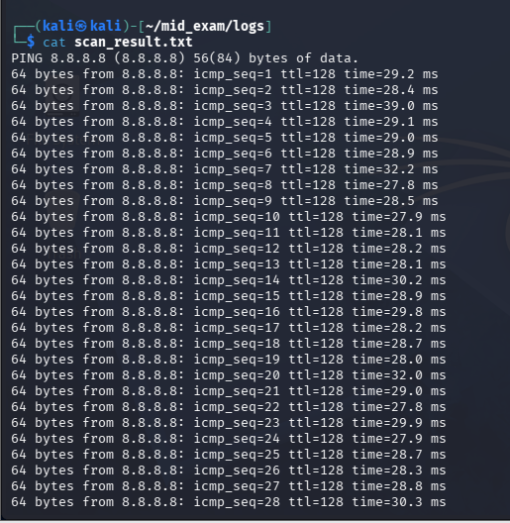
6. Running Process and Monitor system activity:
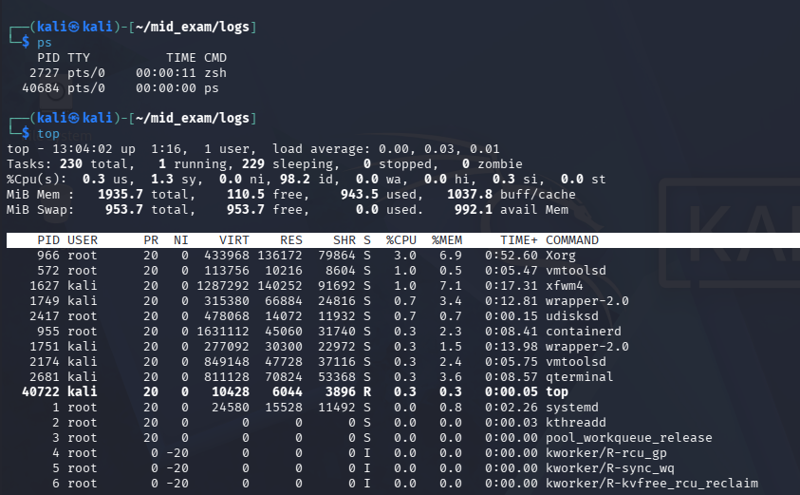
7. MD5 and SHA256 employee_info.txt and save output hash_report.txt
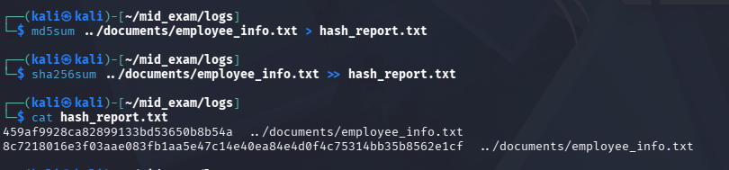
8. Searching for the keyword failed:

